My visit to York Art Gallery

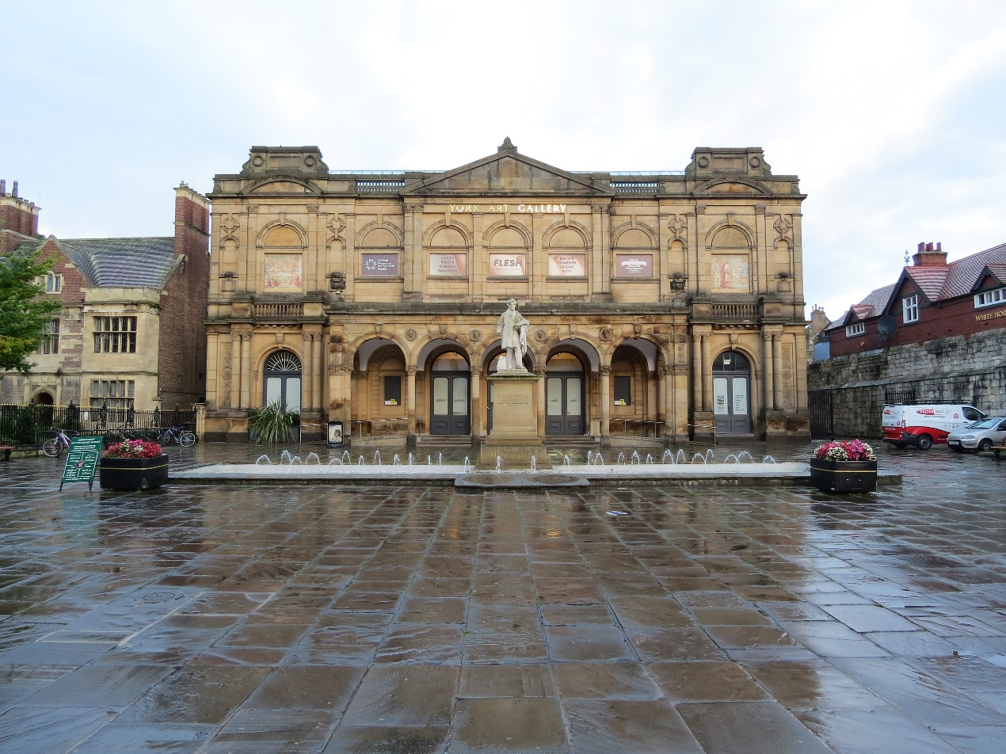

Planning my visit

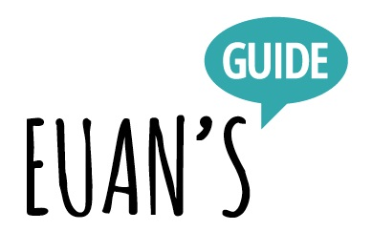

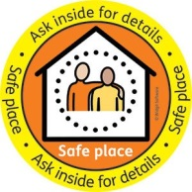

This is the reception area.

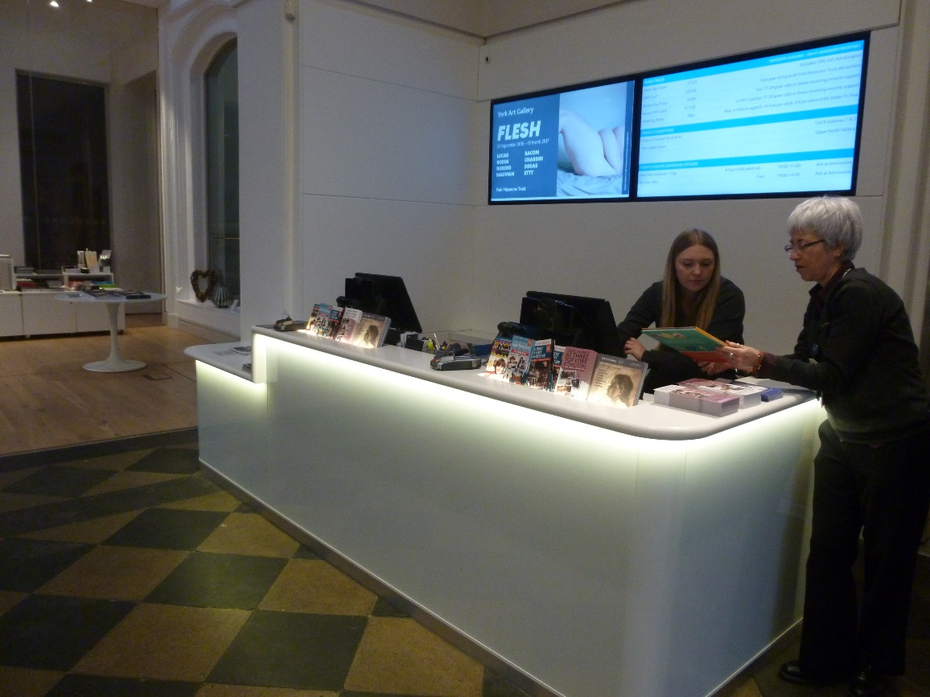

There are people who can help you at the art gallery called the Welcome Team. They wear purple shirts and a name badge. If you have a question you can ask the Welcome Team.

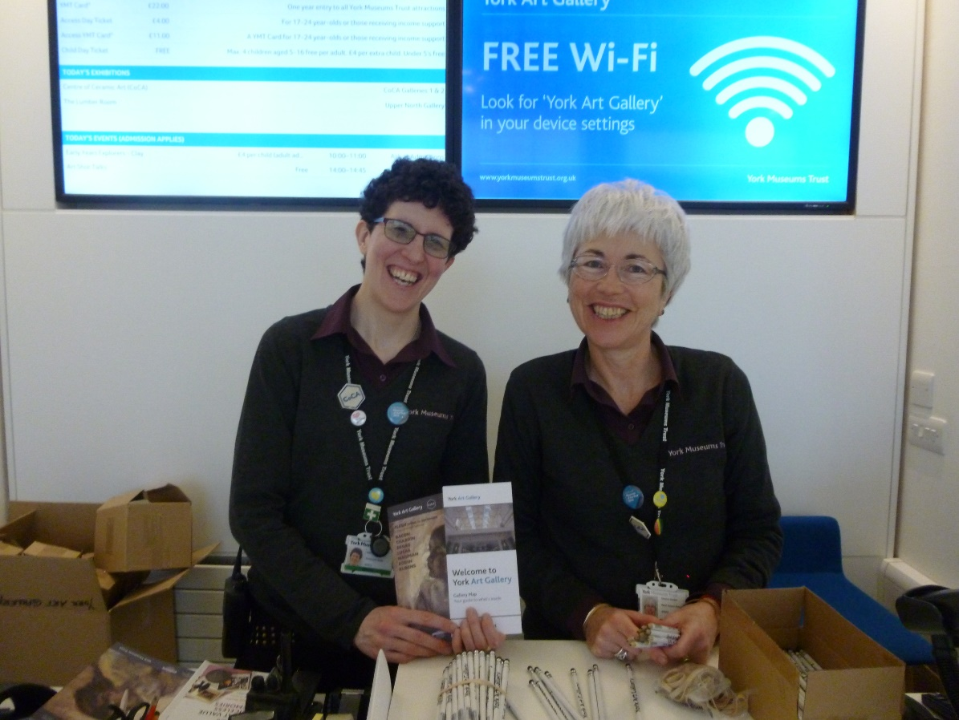
In this first space we have . . .

A café

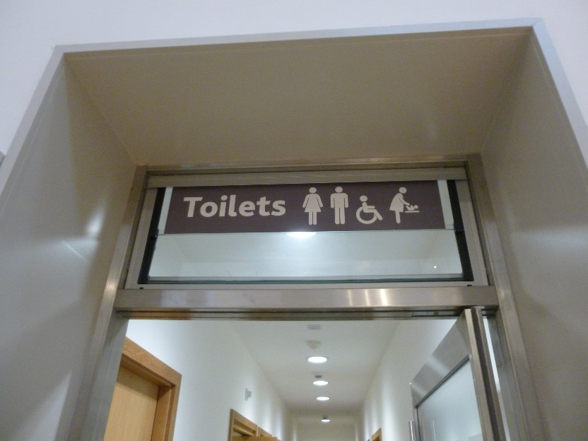
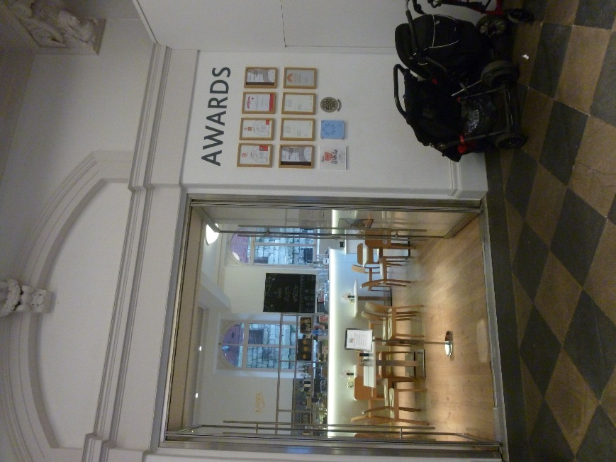
Accessible toilets and baby changing facilities

Lift to the second floor
Shop
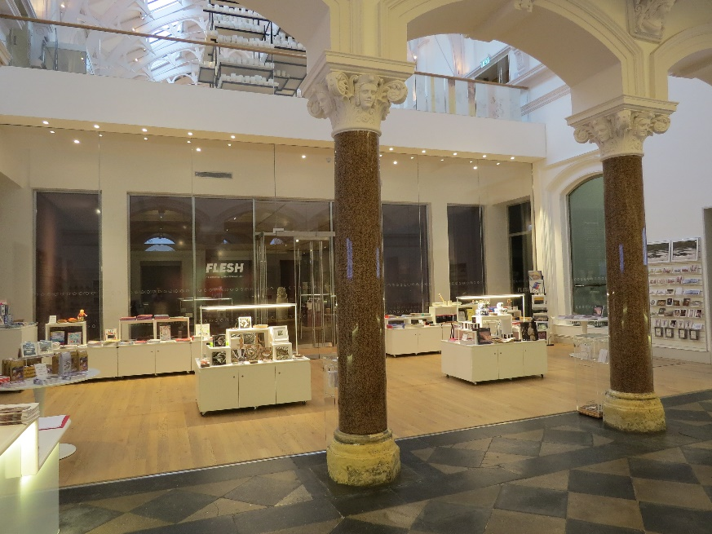
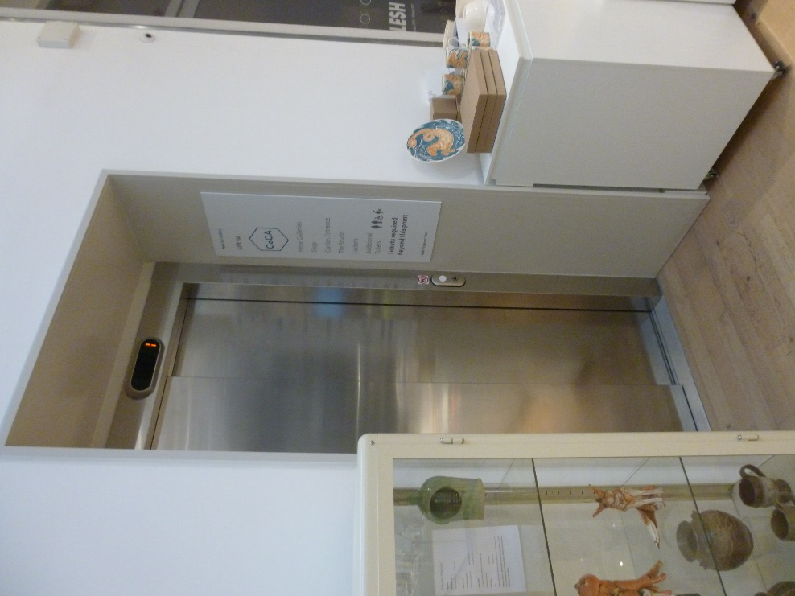

We have stairs that you can use to go to the second floor.

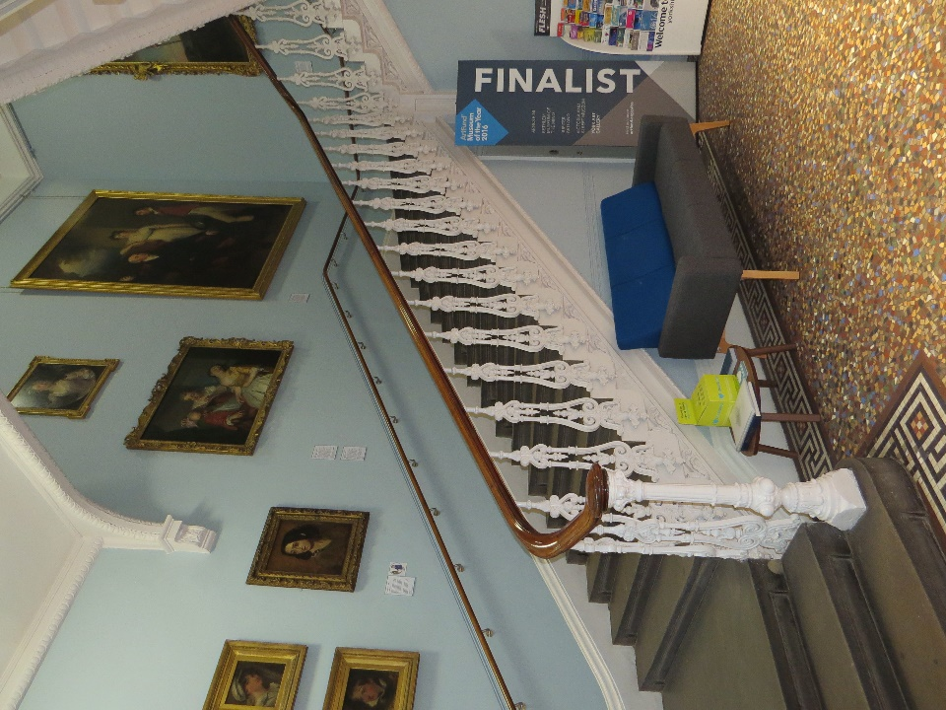

There is also a sofa in this space which is good to use if you want some quiet time away from other visitors.

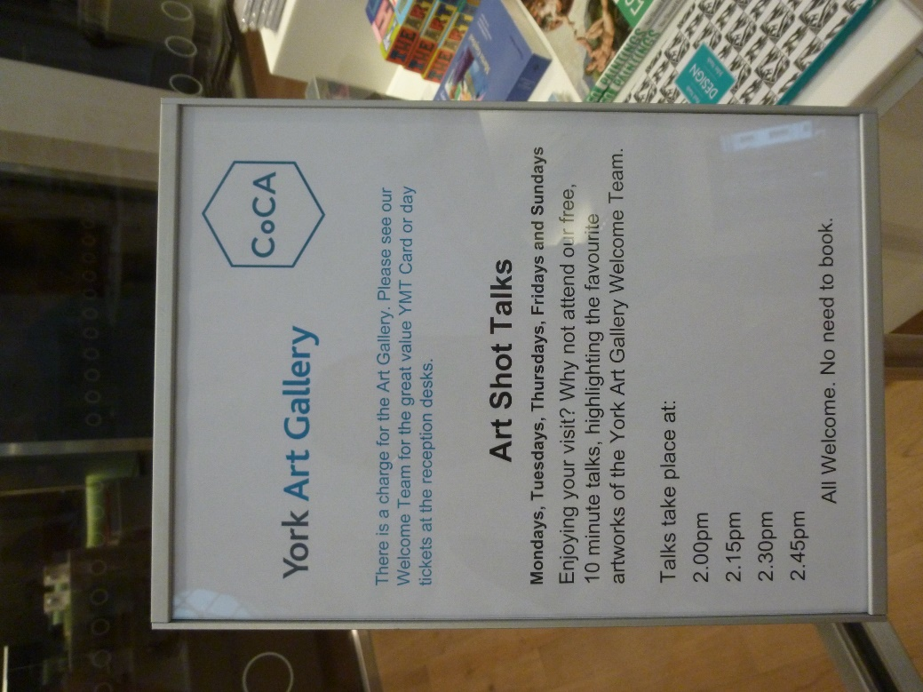

Look out for when our Welcome Team talks are on – you can find out more information on lots of favourite paintings and pots in the gallery.

On the left when you go into the art gallery we have the Project Gallery which is free to look at and shows work done by other children or community groups.

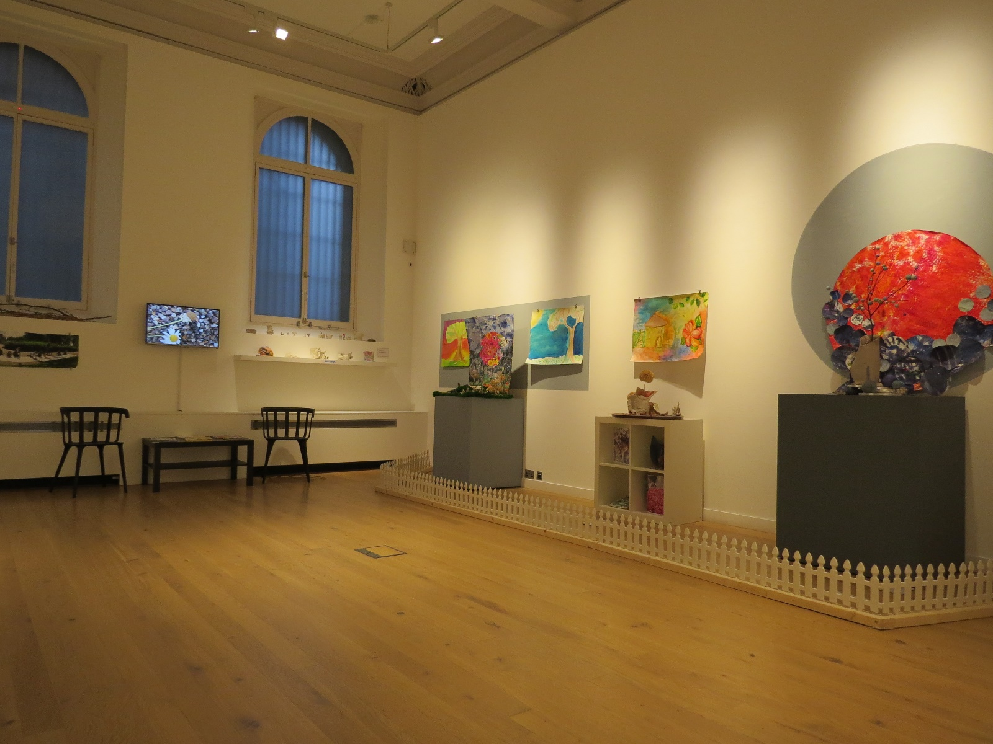

Sometimes the project gallery might have loud music or flashing lights but you can check with the Welcome Team first before you go in.

On the ground floor we have three main galleries. These will change twice a year and show lots of different art in there. Sometimes we get to show art from other museums.
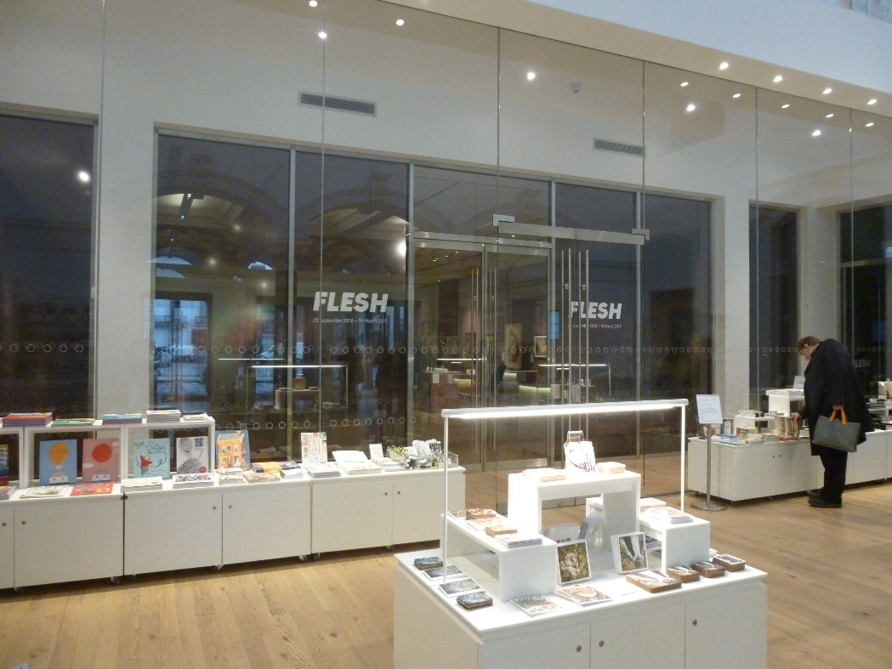

If there is anything that visitors should be aware of in these galleries there will be a notice on the door and you can ask the Welcome Team for help if you are unsure about the art on display. These galleries can be quite dark.
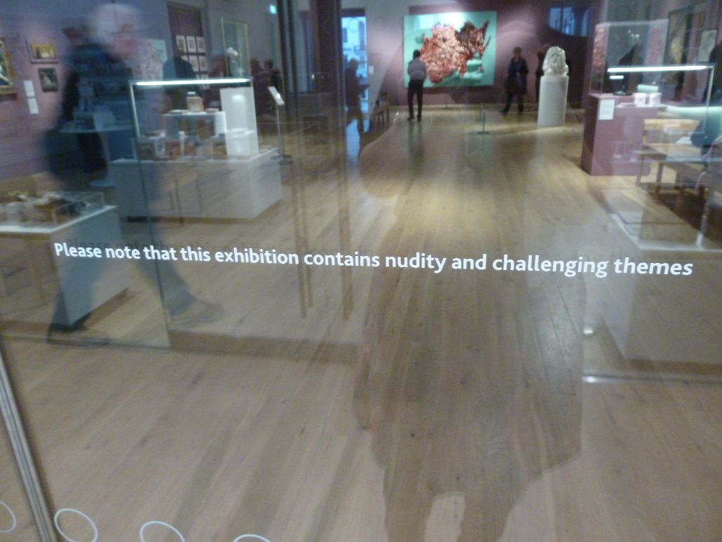

On the second floor we have four gallery spaces.
The first gallery is a little bit dark and has lots of video and sound in there as it is showing contemporary art.

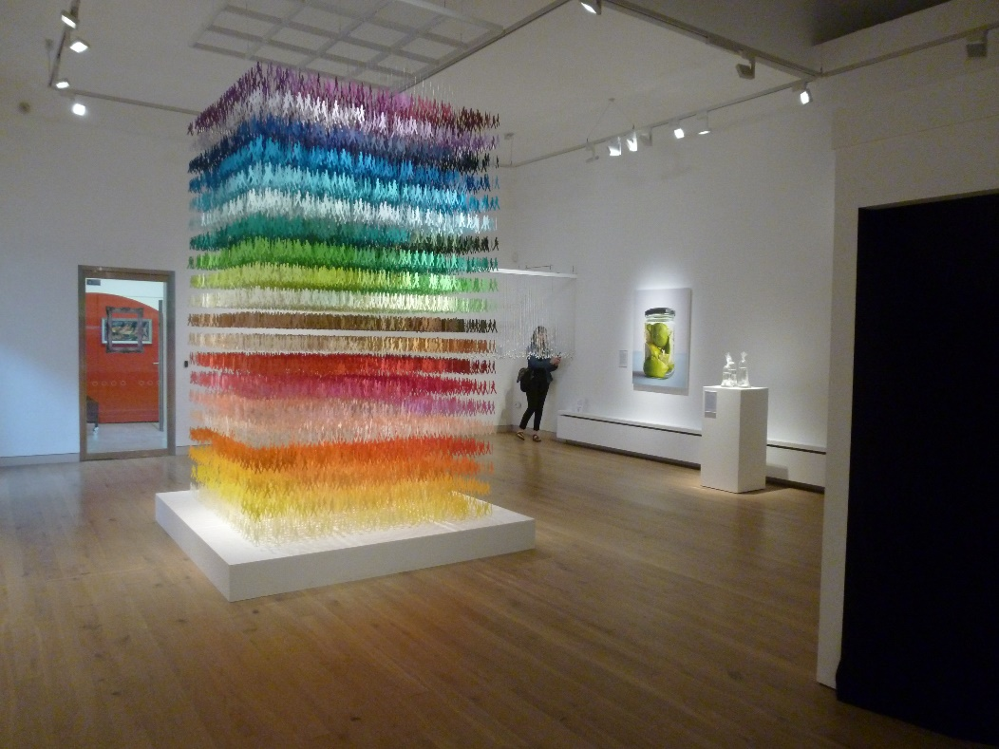

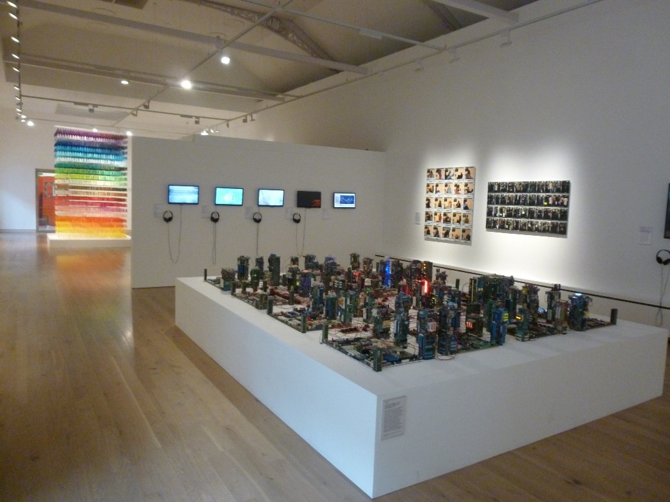

The second gallery is bright and airy. It tells us about the history of art. There are lots of things to touch, listen to, and play with.
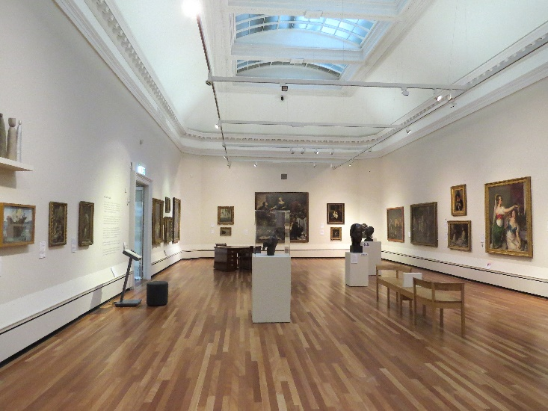
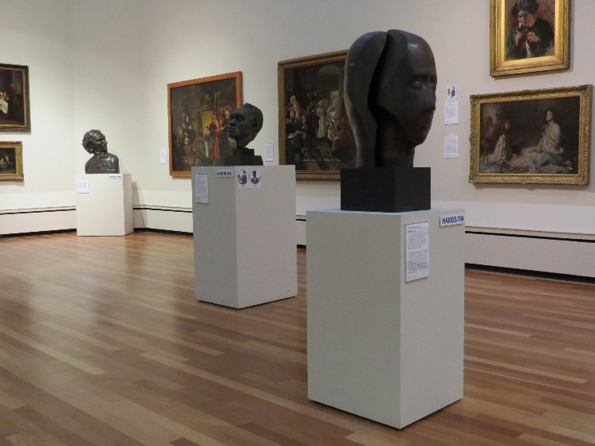

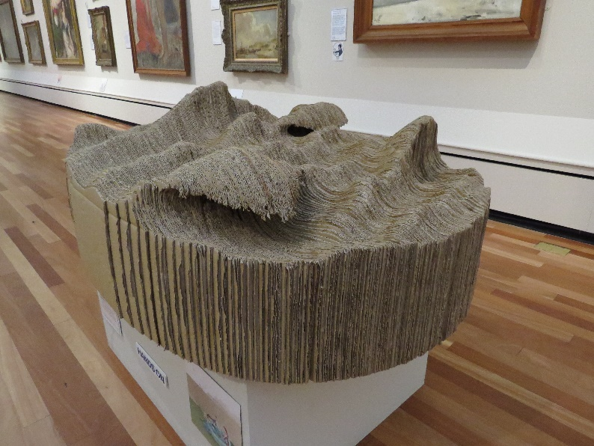

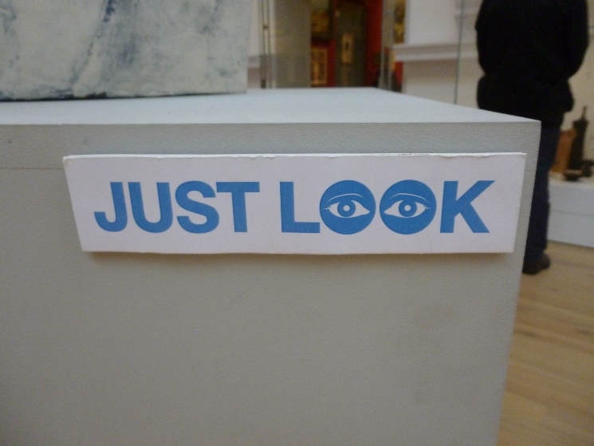
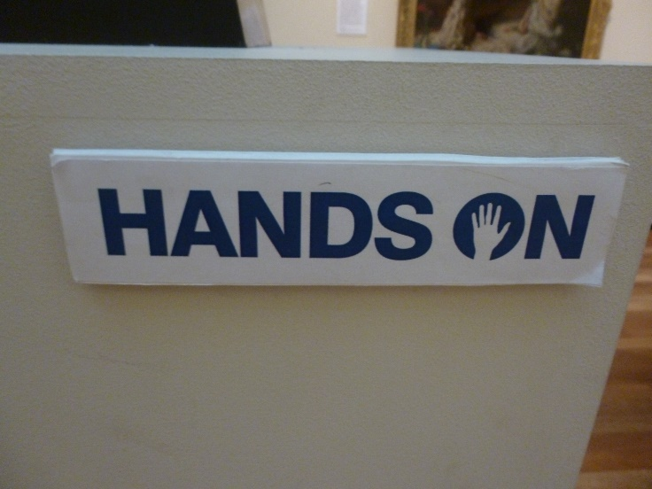

Upstairs, where the lift comes out, we have more accessible toilets and baby changing facilities.

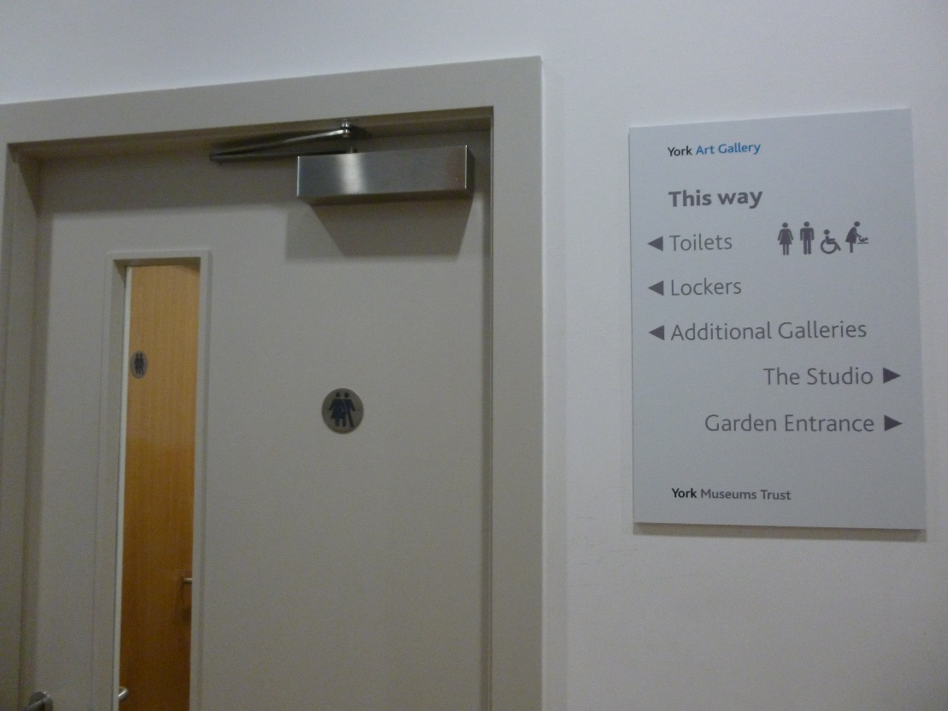

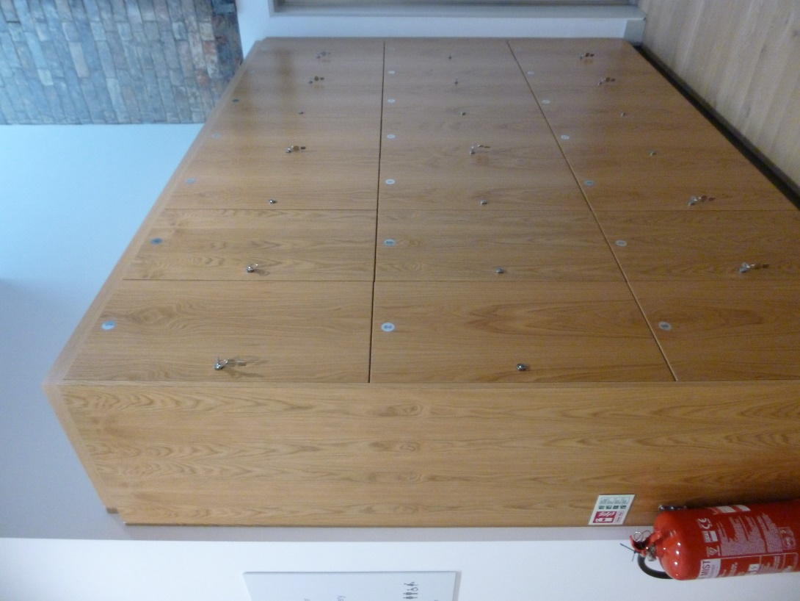

There are also lots of lockers where you can store bags and coats.

The CoCA 1 gallery is usually bright and can be a little bit noisy. There is a sound pod to listen to.

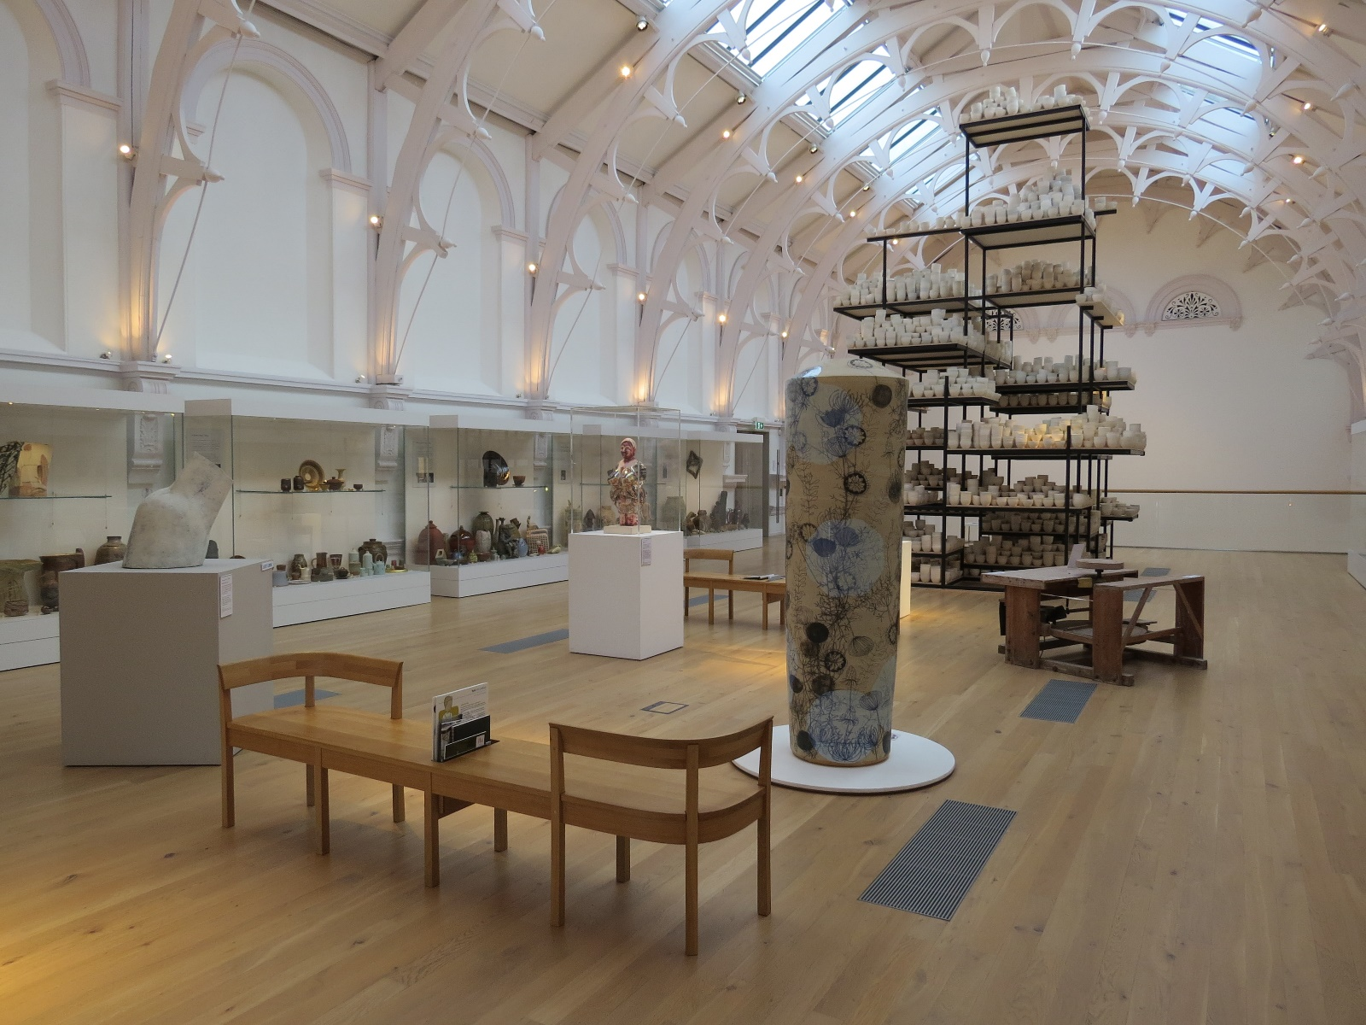

This gallery tells us all about the history of British pots in the 20th and 21st century.

Look out for ‘Melanie’ she has lots of interesting pictures on her.

The CoCA 2 gallery has objects out on open display set out like somebody’s house. There is a video to watch and books you can read.
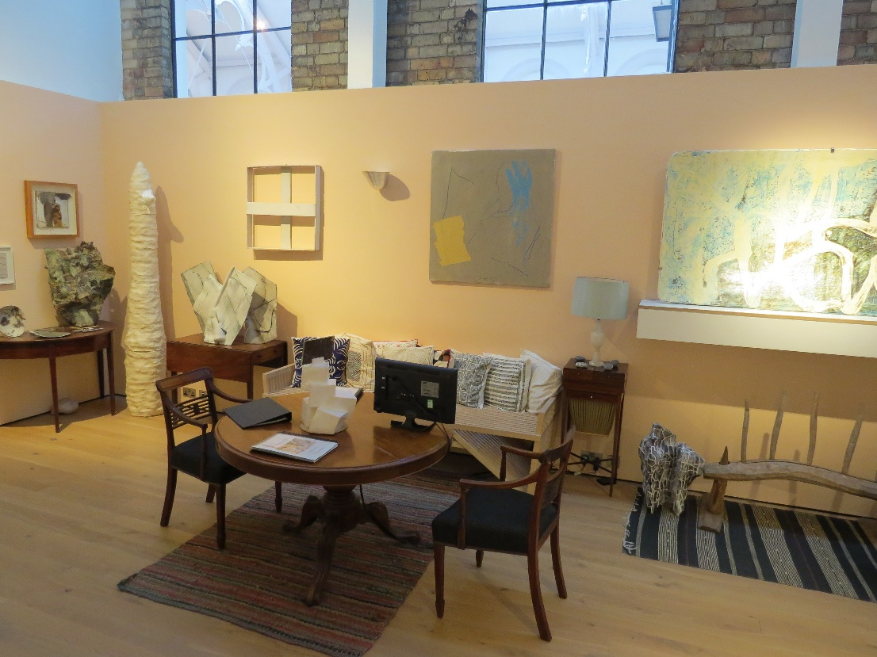

There is also a huge wall full of pots looking at colour and a handling space with lots of lovely pots to touch.

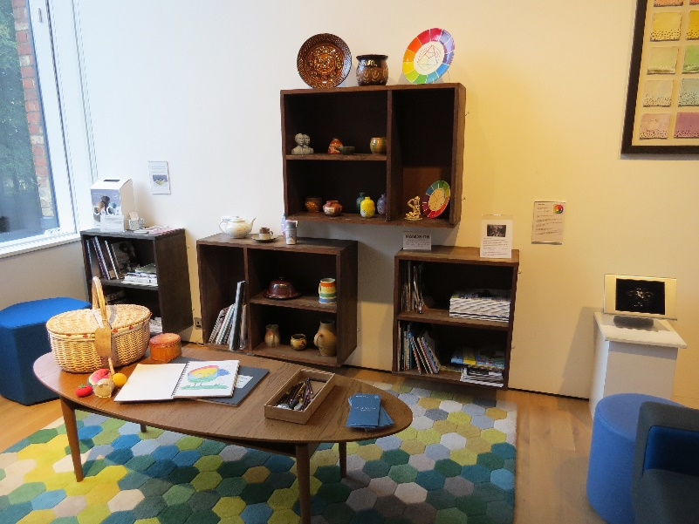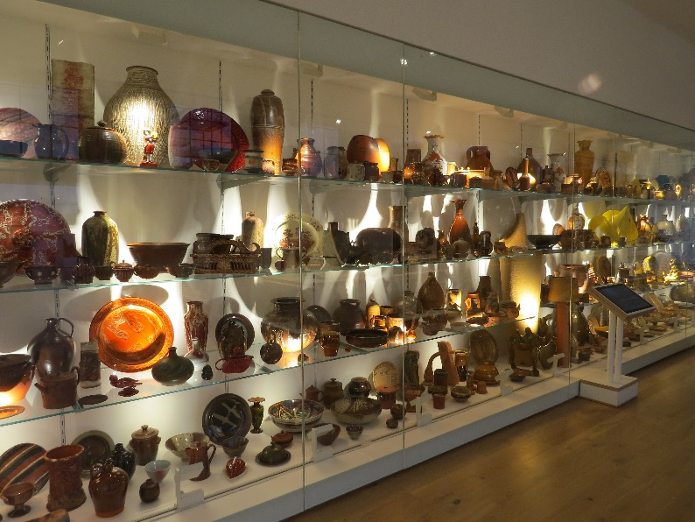

In these two galleries with pots you might see one of our volunteers.
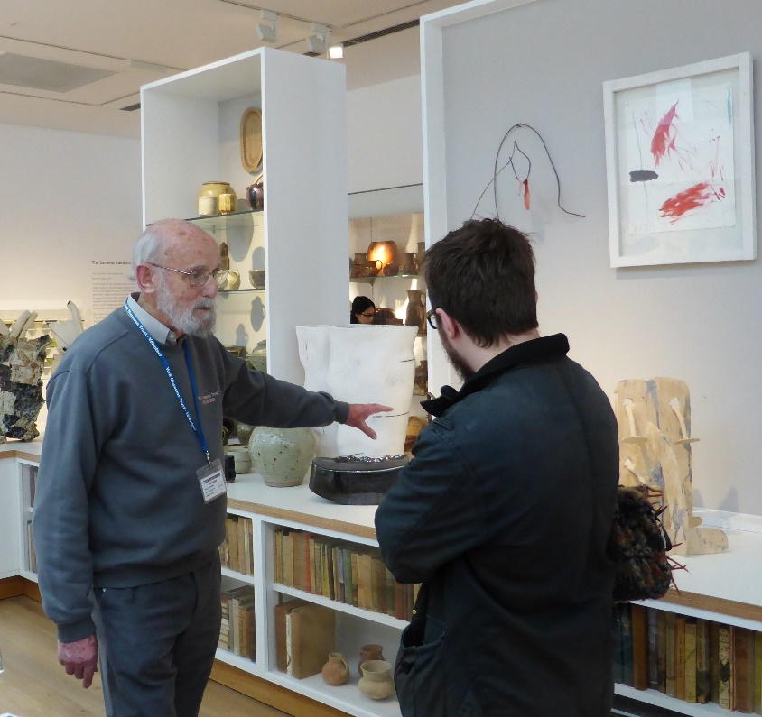

They can help you find out more information about the art and pots that are on display.

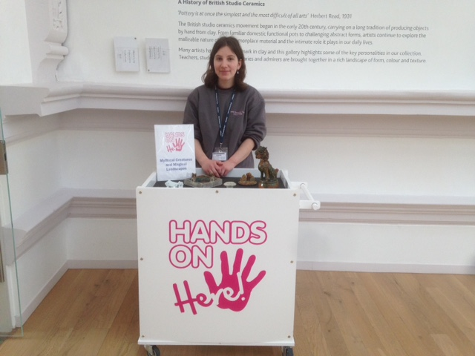

They also have objects that you can handle and learn more about. They are very friendly.

There is a Studio upstairs which is open to the public during school holidays and for people who visit with special groups like schools. When it is open you can make things and play or sit and read.
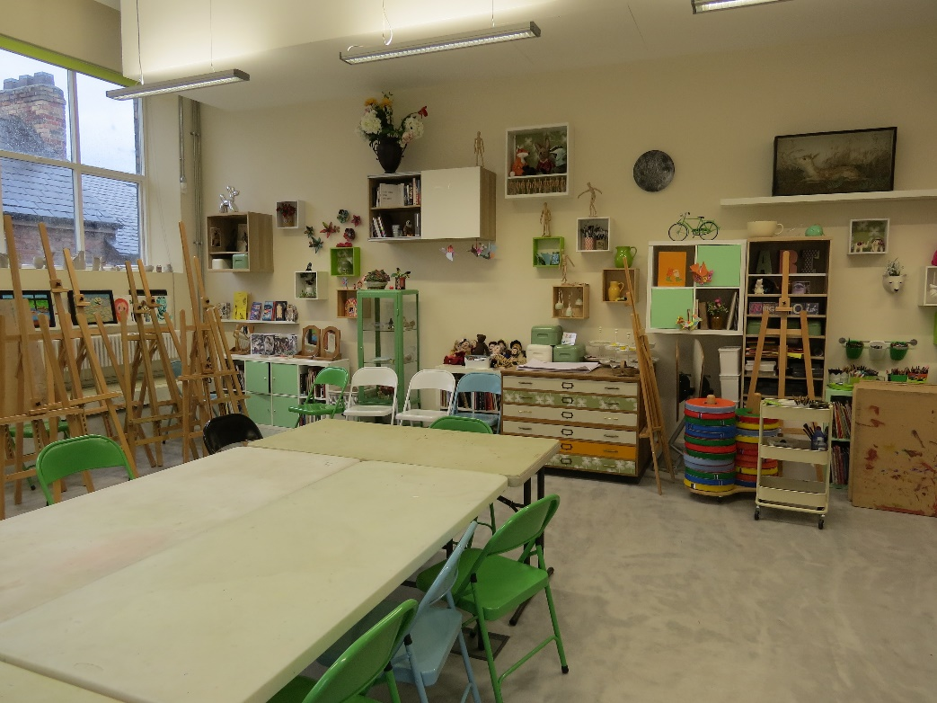

There are sketch pads and pencils hiding in benches in every room in the art gallery that you can use all the time . . . if you can find them!

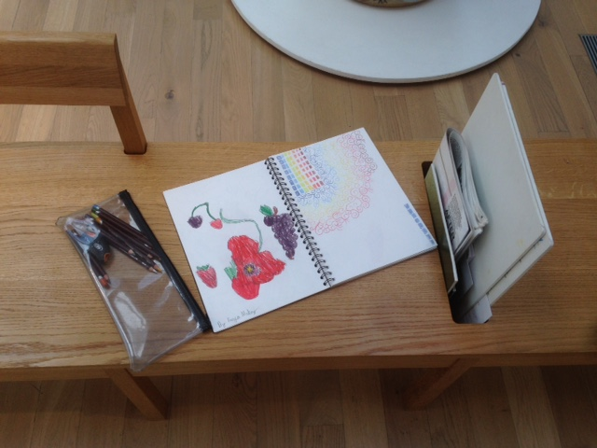

There is another shop upstairs that you can buy things from.
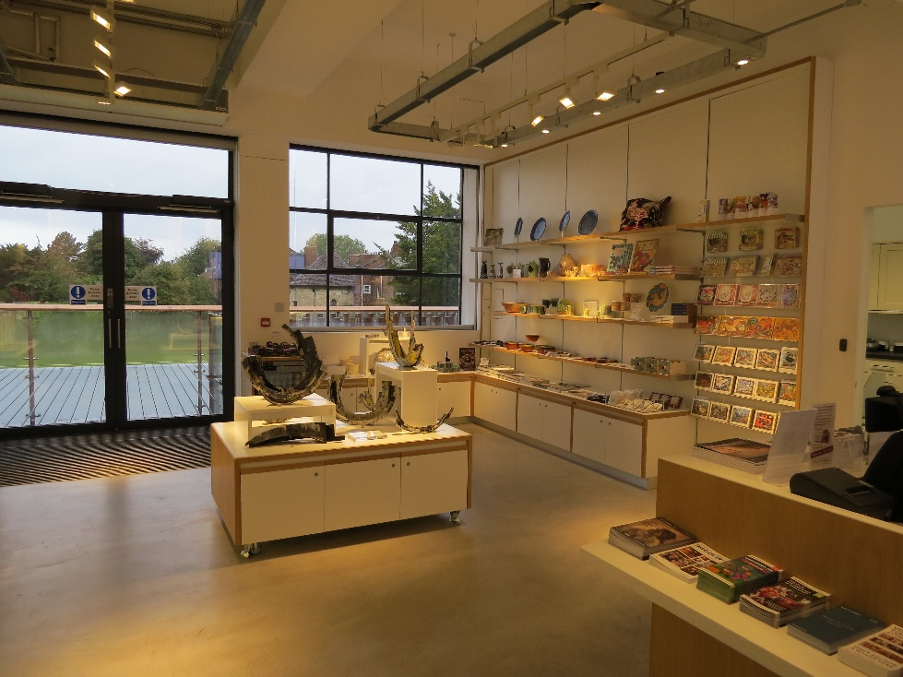

Or you can go out onto the balcony and walk through the Artists’ Gardens and through to the Yorkshire Gardens.

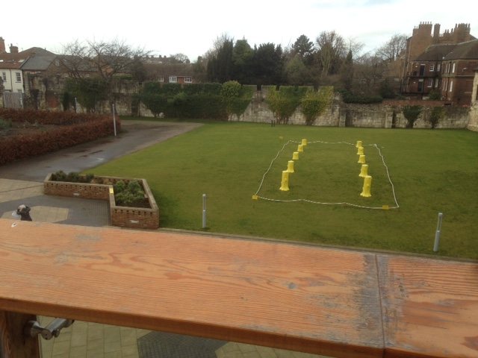

We hope you enjoy your visit and if we can do anything to help you, just ask!

